MidPoint Circle Algorithm
It is based on the following function for testing the spatial relationship between the arbitrary point (x, y) and a circle of radius r centered at the origin:
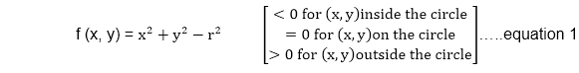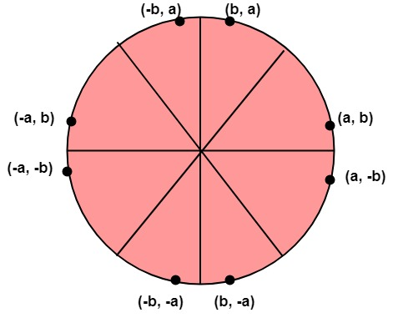
Now, consider the coordinates of the point halfway between pixel T and pixel S
This is called midpoint (x_{i+1},y_{i}-) and we use it to define a decision parameter:
P_{i}=f (x_{i+1},y_{i}-) = (x_{i+1})²+(y_{i}-)²-r² ...............equation 2
If P_{i} is -ve ⟹midpoint is inside the circle and we choose pixel T
If P_{i} is+ve ⟹midpoint is outside the circle (or on the circle)and we choose pixel S.
The decision parameter for the next step is:
P_{i+1}=(x_{i+1}+1)²+(y_{i+1}-)²- r²............equation 3
Since x_{i+1}=x_{i+1}, we have
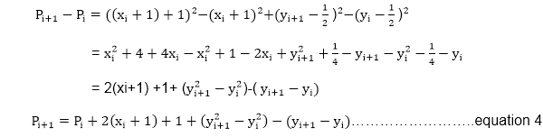
If pixel T is choosen ⟹P_{i}<0
We have y_{i+1}=y_{i}
If pixel S is choosen ⟹P_{i}≥0
We have y_{i+1}=y_{i}-1
We can continue to simplify this in n terms of (x_{i},y_{i}) and get
Now, initial value of P_{i} (0,r)from equation 2
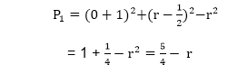
We can put ≅1
∴r is an integer
So, P₁=1-r

Algorithm:
Step1: Put x =0, y =r in equation 2
We have p=1-r
Step2: Repeat steps while x ≤ y
Plot (x, y)
If (p<0)
Then set p = p + 2x + 3
Else
p = p + 2(x-y)+5
y =y - 1 (end if)
x =x+1 (end loop)
Step3: End

Program to draw a circle using Midpoint Algorithm:
- #include <graphics.h>
- #include <stdlib.h>
- #include <math.h>
- #include <stdio.h>
- #include <conio.h>
- #include <iostream.h>

- class bresen
- {
- float x, y,a, b, r, p;
- public:
- void get ();
- void cal ();
- };
- void main ()
- {
- bresen b;
- b.get ();
- b.cal ();
- getch ();
- }
- Void bresen :: get ()
- {
- cout<<"ENTER CENTER AND RADIUS";
- cout<< "ENTER (a, b)";
- cin>>a>>b;
- cout<<"ENTER r";
- cin>>r;
- }
- void bresen ::cal ()
- {
- /* request auto detection */
- int gdriver = DETECT,gmode, errorcode;
- int midx, midy, i;
- /* initialize graphics and local variables */
- initgraph (&gdriver, &gmode, " ");
- /* read result of initialization */
- errorcode = graphresult ();
- if (errorcode ! = grOK) /*an error occurred */
- {
- printf("Graphics error: %s \n", grapherrormsg (errorcode);
- printf ("Press any key to halt:");
- getch ();
- exit (1); /* terminate with an error code */
- }
- x=0;
- y=r;
- putpixel (a, b+r, RED);
- putpixel (a, b-r, RED);
- putpixel (a-r, b, RED);
- putpixel (a+r, b, RED);
- p=5/4)-r;
- while (x<=y)
- {
- If (p<0)
- p+= (4*x)+6;
- else
- {
- p+=(2*(x-y))+5;
- y--;
- }
- x++;
- putpixel (a+x, b+y, RED);
- putpixel (a-x, b+y, RED);
- putpixel (a+x, b-y, RED);
- putpixel (a+x, b-y, RED);
- putpixel (a+x, b+y, RED);
- putpixel (a+x, b-y, RED);
- putpixel (a-x, b+y, RED);
- putpixel (a-x, b-y, RED);
- }
- }
Output:
